**Stage Design**

In addition to enemies, traps and gimmicks will be included in the game’s levels, often enabling, or complicating, shortcuts.

**Traps:**

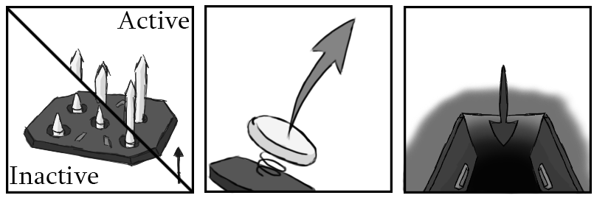

Figure 1 - Traps: Spike, Spring, Trapdoor

For example, the spike trap. Two types exist- the timed trap, triggering independently after a small delay and resetting, and the proximity trap, triggering after the player moves over it. The proximity trap will have an adjustable delay, to allow or disallow quick reactions to save yourself, and a cooldown to prevent it triggering immediately after firing.

The timed trap could work well with the shrew caravan for example, taking out the mother and causing the babies to charge. Traps that hurt you will also hurt enemies that enter the range, and enemies will be able to trigger certain traps. Other traps to impact combat could include sticky floors that slow you down, flame traps that spew fire a distance away, and trapdoors that open to reveal new, usually slower, parts of the level when stepped on. Gimmicks like springs (bouncing the player up) or fans (pushes the player) will alter platforming.

**Stage Gimmicks:**

Buttons that link objects together, such as opening a set of gates, can create action sequences easily. Other gates can require beating certain enemies to open or finding keys within the level. Since this is a speed-based game we will always have a secondary path accessible to the player for skipping any movement locking areas, requiring high-skill gameplay to complete. For players experiencing the game for their first time, the slower areas will act as necessary skill gates to learn the combat while also pushing for exploration of the levels to find the faster routes.

**Weapon and Level Interactions:**

Another key level idea is to utilise a certain weapon to great effect. For example, the shockwave effect of the shield could be used to push enemies off a narrow bridge into hazards below, or a wall-run-able wall could curve around to reveal a secret area with the daggers. Multiple weak enemies like dizzy chargers could be placed after a hard area to recover health using the scythe, accessible via zipline, and a medium sized gap could be crossed by grappling a Lobuzz using the hook shot. All of these can be included to help a player learn to use the abilities also.

**Shortcuts and Detours:**

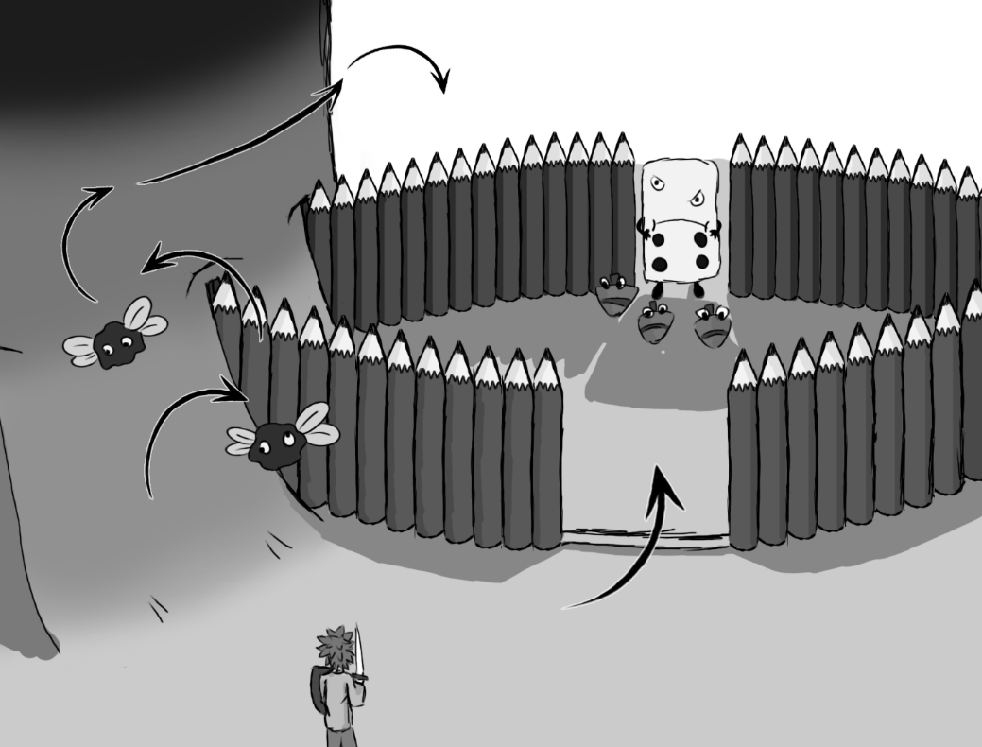

Figure 2 - Enemy ambush room with potential skip accessible via grapple-shot.

Shortcuts such as the Lobuzz gap cut, and detours, such as the healing area for the scythe matter greatly. Risk vs reward style gameplay, where the reward is a time save for pulling off a trick (or choosing to not slow down and heal) is great for speed-running, whereas an “apples and oranges” choice between alternate routes (combat or platforming for example) lets players play to their strengths.